**Відповіді на лекцію №11**

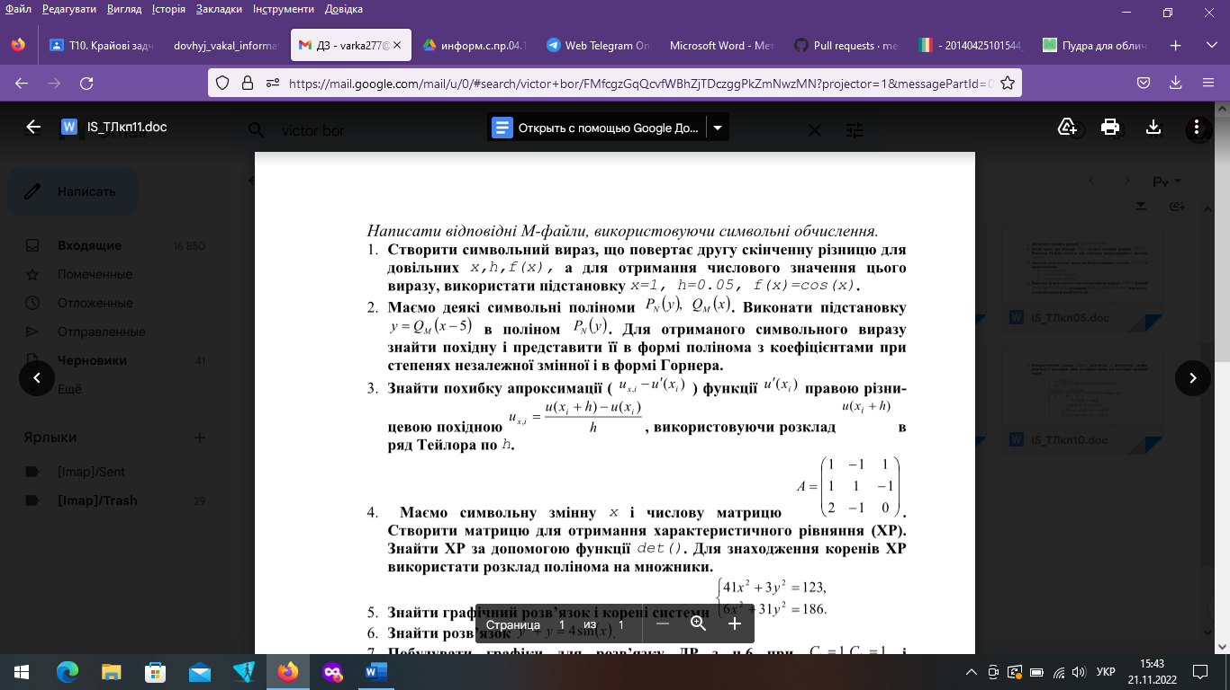

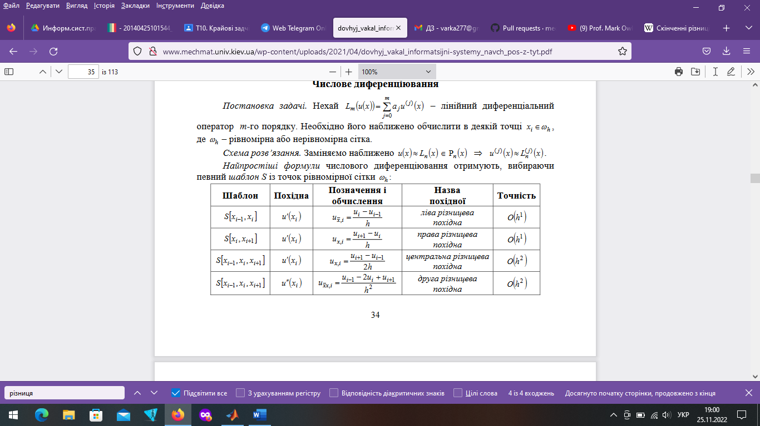

function p_1  
clear;

clc;

z = sym('ff(x)')

syms x h;  
rdz=(subs(z,x,x-h,x+h)-2*z)/h.2

nh=0.05;nx=1;

ff=@(t)(cos(t));  
s=subs(subs(rdz,h,'nh'),x,'nx')

es=vpa(s)   
en=eval(s)



clear

clc

syms x y

P(y), Q(x)

s = subs(P,Y,Q*(x-5));

k = diff(s);

V = collect(s,var);

G = horner(s);



%% pl13_5.m  
clear; clc  
syms x h;  
zmh = sym('u(x+h)');  
z0h = sym('u(x)');  
sm = taylor(zmh, 7, x, h);  
Oh = simplify((sm-z0h)/h-diff(z0h,x,2));  
Oh = subs(Oh, x, 'Xi'); Oh = collect(Oh);  
z = char(Oh); k = findstr(z,'h');

z = z(k(end-1)+3:end);  
Oh = simple(sym(z))

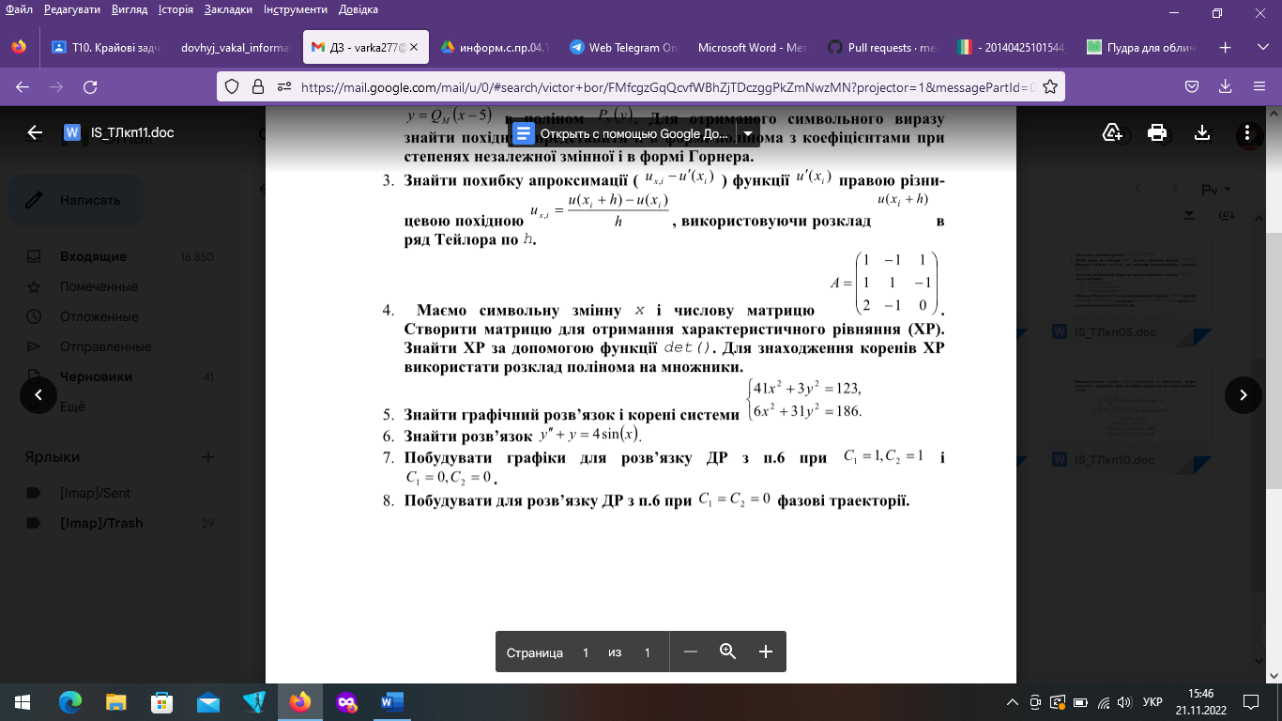

clear

clc

syms x

A = [1 -1 1; 1 1 -1; 2 -1 0];

H = [-x, 0, 0; 0, -x, 0; 0, 0, -x];

K=A.*H;

W=det(A)

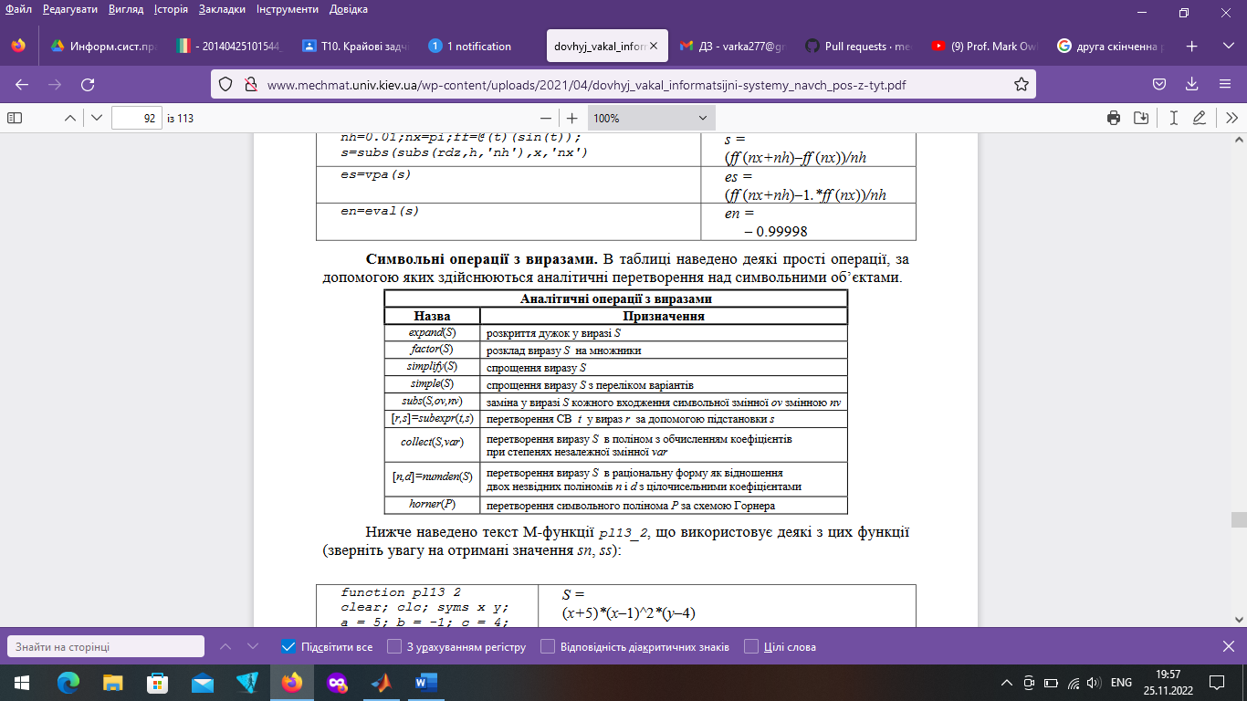



%% pl13_9.m  
clear all, close all, clc

ezplot('41*x^2+3*y^2-123’,[-2,2]), hold on  
ezplot('6*x^2+31*y^2-186',[-2,2]), grid on  
S = solve('41*x^2+3*y^2-123=0',...  
'6*x^2+31*y^2-186=0', 'x', 'y');  
s = strcat(s1,' б)\n',s2);  
fprintf(s);  
n = length(S.x);  
for k = 1 : n  
fprintf('%17.8f |%17.8f\n', double(S.x(k)), double(S.y(k)));  
end  
pause, clear all, close all







function my_1

syms x

z = dsolve('x(t)','D2y+y=4*sin(x)');

u = subs(subs(z,C1,1),C2,1);

h = subs(subs(z,C1,0),C2,0);

ezplot(u,[-5,5,-5,5]); hold on;

ezplot(h,[-5,5,-5,5]); grid on; pause;

ParametricPlot[Evaluate[xyc[1, 1]], {t, 0, 10}, PlotRange -> All]

ParametricPlot[Evaluate[Table[xyc[1, 0], {0, 1, 10}]], {t, 0, 10},

 PlotRange -> All]

ParametricPlot[Evaluate[Table[xyc[0, 1], {0, 1, 10}]], {t, 0, 10},

 PlotRange -> All]